**Backlogs and User Stories**

**Sprint organization**

In this project, we used Azure DevOps Server as a collaborative platform to organize and manage the project. All the members of the team have access to the platform and can see the project components, the user stories, the sprint schedule, tasks etc.

The Azure DevOps platform uses a few specific terminology for the organization of the backlog. The user stories are grouped under a specific feature and multiple features are grouped under a broad category named *Epic*.

The backlog of the system is divided into two *Epic* categories, *Users* and *Documentation*, which we consider as two necessary elements of the product development and organization. The *Users* is subdivided into 3 features, namely, *Employee*, *Supervisor* and *User*. The *Documentation* is subdivided into 4 features, *Logic diagram*, *Class diagram*, *Use Case diagram*, *Sequence diagram*. The user stories are created, placed into the relevant categories and assigned to specific sprints.

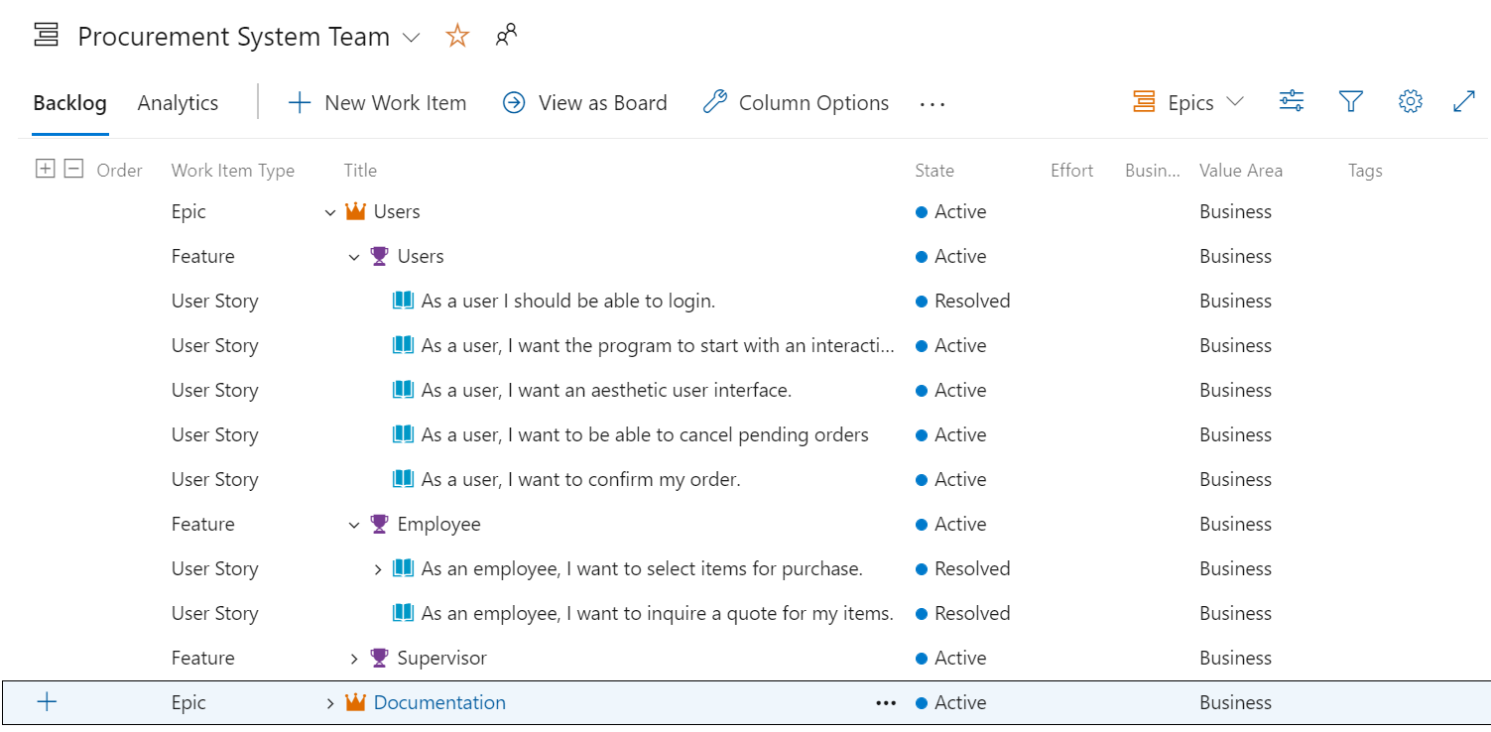

Categorization of the *Users* Epic and the *Users* and *Employee* features and their user stories on Azure Devops.

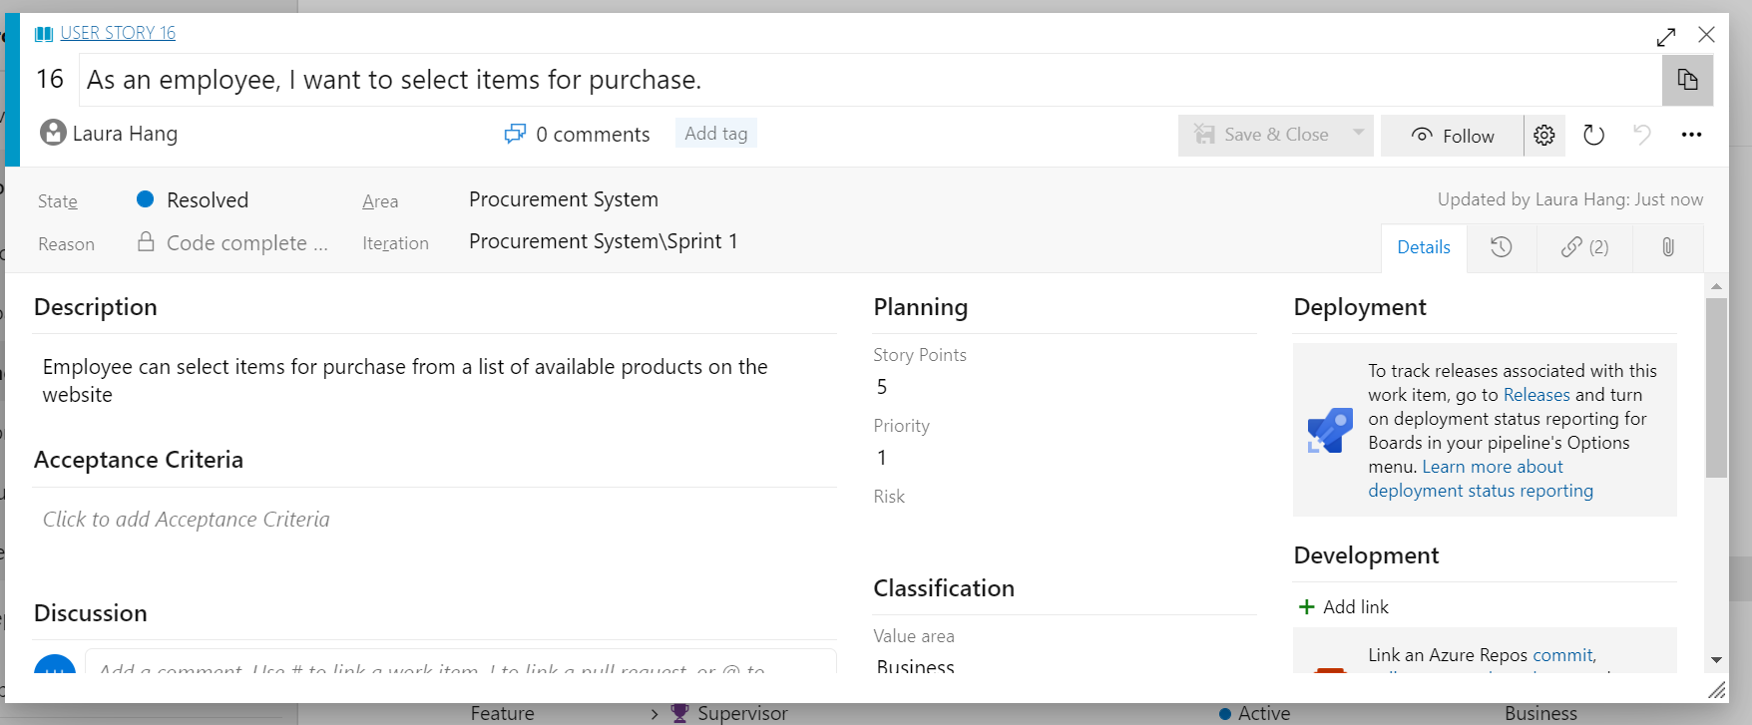

Example of a user story record on Azure DevOps

**Story points**

The stories are appointed a priority value and a story point value. The priority is a value from 1 to 4, with 1 being the highest priority and 4 the lowest.

The user stories are estimated using story points which represent the effort needed to complete the story. The units are values of the fibonacci sequence, 1, 2, 3, 5, 8, 13, 21, 34, 55, 89. We used an iterative method of planning poker to estimate the story points. All the members met in person and set an online planning poker round and discussed the user stories.

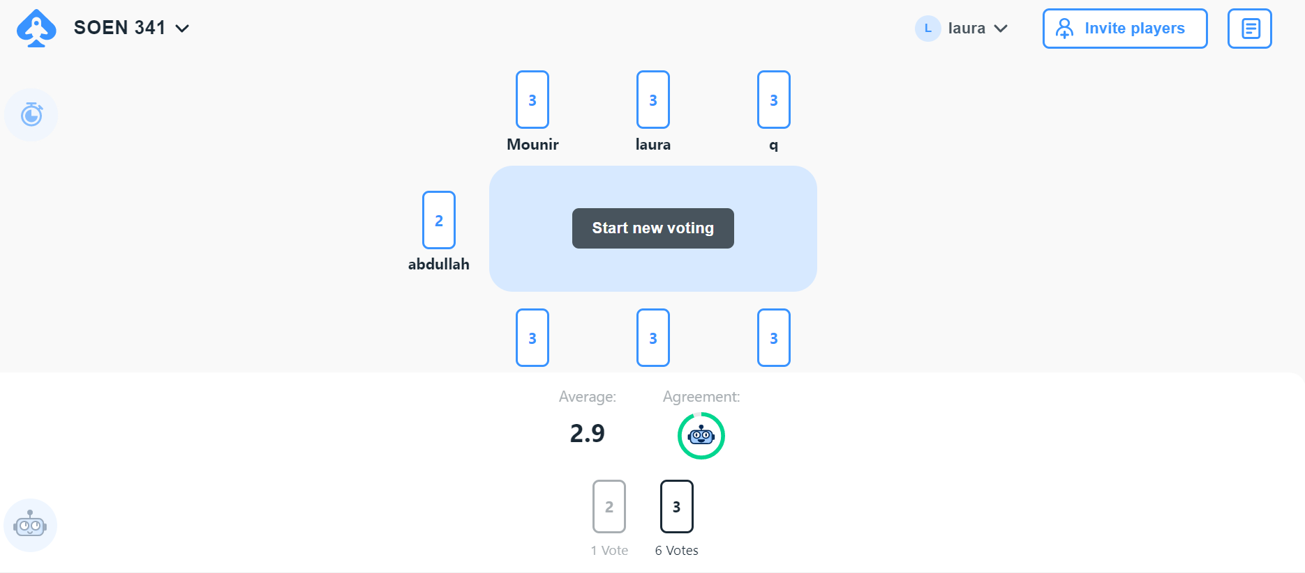

Figure : Planning poker voting round for the “I want to access the order history” user story.

The user stories from the Azure DevOps platform are summarized in the following product backlog table:

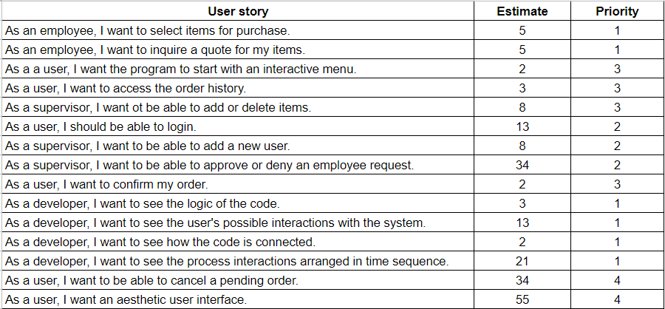

Table: Product backlog, user stories with their story points estimate and priority value

The sprint 1 backlog is summarized in the following:

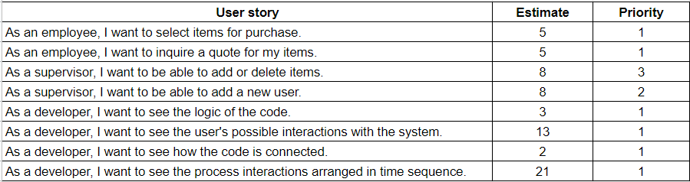

Table: Sprint 1 backlog, user stories with their story points estimate and priority value

The sprint 2 backlog is summarized in the following table:

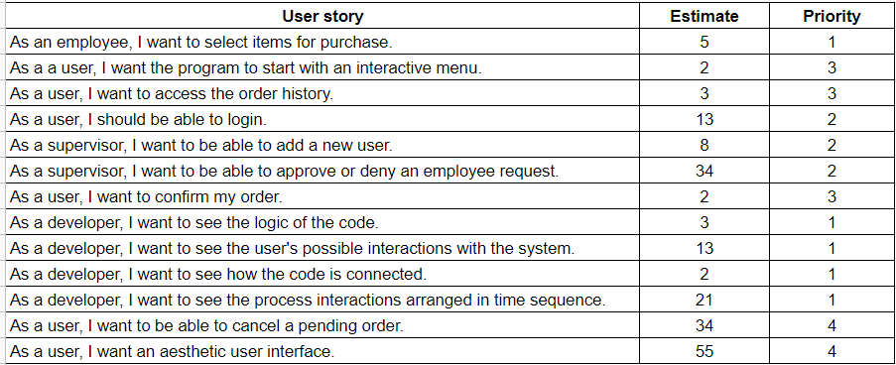

Table: Sprint 2 backlog, user stories with their story points estimate and priority value